## **Agent Name: Artemis**

*The Decentralized AI Co-Creation Engine for 3D Worlds*

## **Subnets Leveraged**

1. **404—GEN (Subnet 17)** – Procedural AI for 3D/virtual world generation.
2. **BitAgent - Rizzo (Subnet 20)** – Agentic tool-calling and orchestration.
3. **Neural3D (Subnet 46)** – NFT minting for immersive, metaverse-ready assets.
4. **ComputeHorde (Subnet 12)** – Scalable compute backbone for high-load tasks.

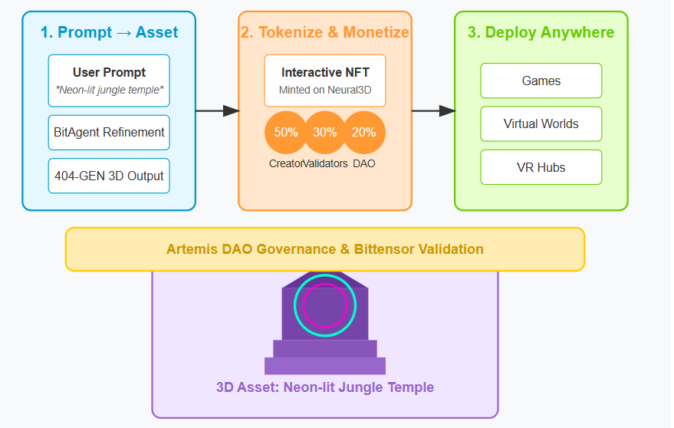

Artemis Operational Flow

**Use Case & Product Vision**

### **The Problem**

* Today’s AI art tools offer zero real ownership, and 3D creation remains a closed-loop game for technical elites.
* Collaborative economies are fragmented, and monetizing creativity is clunky, centralized, and often unfair.

### **Artemis: The Solution**

Artemis is a fully on-chain, co-creative AI agent that transforms prompts into high-fidelity 3D assets—then turns those into income-generating NFTs. It’s a creator-first, validator-powered, and DAO-governed pipeline.

#### 

#### **How It Works**

1. **Prompt → Asset**:  
    A user submits: *"A neon-lit jungle temple with ancient tech.”* BitAgent refines it via chat, then routes it to 404—GEN for instant 3D output.
2. **Tokenize & Monetize**:  
    The asset is minted as an **interactive NFT** on Neural3D with embedded royalties:  
   * **50%** to the creator
   * **30%** to validators (split across subnets used)
   * **20%** to the Artemis DAO for upgrades and bounties
3. **Deploy Anywhere**:  
    Assets integrate directly into games, virtual worlds, or VR hubs, backed by Bittensor.

## **Live Demo / On-Stage Moment**

**“TAO World: Live”**

* The audience submits prompts in real time.
* Artemis co-creates a live virtual gallery using BitAgent and 404—GEN.
* Neural3D instantly mints the assets as NFTs, and they’re displayed in a browser-based VR space.
* Judges see TAO culture, AI magic, and creator ownership converge—all on one stage.

## **Ecosystem Design & Economic Flywheel**

| **Player** | **Incentive** | **Subnet Impact** |
| --- | --- | --- |
| **Creators** | Earn royalties + govern style evolution | Drives demand for 404—GEN, Neural3D |
| **Validators** | Fee rewards from cross-agent activity | Expands BitAgent + subnet utility |
| **$BID Stakers** | Vote on upgrades, unlock new features | Fuels DAO activity & asset innovation |

#### 

#### **Why Artemis Stands Out**

* **Hyper-synergistic Subnet Design**: Each subnet handles what it’s best at—generation, orchestration, minting.
* **Built for the New Creative Economy**: 3D + AI + crypto is a high-growth, untapped trifecta.
* **DAO-Driven Evolution**: $BID holders literally decide what styles and themes get prioritized.

## **Example Journey: Prompt to Passive Income**

| **Step** | **Action** | **Earnings** |
| --- | --- | --- |
| 1. Prompt | "Floating cyberpunk dojo in the clouds" | — |
| 2. Agent Chat | Refined via BitAgent with user feedback | — |
| 3. 3D Generation | 404—GEN creates immersive GLTF file | — |
| 4. NFT Minting | Listed on Neural3D marketplace | Earns 50% royalties |
| 5. Sale & Resales | Sells for $100 → earns $50 instantly + future royalties | Recurring income |
| 6. Governance | Stakes $BID to vote on new shader pack integrations | Asset value ↑ |

## **Artemis Tokenomics**

### **Revenue Split**

| **Recipient** | **Share** | **Purpose** |
| --- | --- | --- |
| Creator | 50% | Direct sale + lifetime royalties |
| Validators | 30% | Incentivize infrastructure across 3+ subnets |
| DAO Treasury | 20% | Fuel proposals, bounties, and future collabs |

### 

### **$BID Token Utility**

| **Utility** | **Impact** |
| --- | --- |
| Governance | Stake $BID to vote on asset styles, integrations, bounties |
| Style Upgrades | Fund next-gen styles: e.g., “Pixar”, “Vaporwave”, etc. |
| Fee Discounts | Lower mint fees for $BID holders |

## 

## **Final Pitch: Artemis = Culture + Code + Crypto**

Artemis isn’t just another AI agent—it’s the **creative nervous system** of the TAOverse.

* **For Creators**: It’s fast, fair, and financially rewarding.
* **For Validators**: It unlocks multi-subnet utility and long-term fees.
* **For the Ecosystem**: It’s a launchpad for VR, games, AI art, and community-driven evolution.